| [◄ December](https://www.wincalendar.com/Holiday-Calendar/December-2023" \o "December 2023) | **January 2024** | | | | | [February ►](#February_2024" \o "Jump to February) | |
| --- | --- | --- | --- | --- | --- | --- | --- |
| **Sun** | **Mon** | **Tue** | **Wed** | **Thu** | **Fri** | | **Sat** |
|  | 1  Happy New Year | 2  Pre-Planning | 3  Pre-Planning | 4  Code of Conduct & Expectations | 5  Code of Conduct, syllabus & Expectations | | 6 |
| 7  Learning Targets  1.I can use proper spotting and exercise techniques  2.I can demonstrate safe lifting techniquest  Success:  -Students are using the resources provided and following them to complete exercises  -students can explain the importance of using the proper techniques when completing exercises  3.I can demonstrate proper warm up protocol for lifetime physical activity  4.I can perform skills that contribute to health related fitness  Success:  -Students complete warmup prior to fitness activities  -Students can explain the purpose of warming up  -students can follow rules and compete against peers in various rec games  5.I can explain the importance of being CPR certified  Success:Students can define list the steps from properly performing CPR and explain the importance of giving compressions even if you are not comfortable with giving breaths | 8  Do Now: notebook setup instructions  **First Aid -16.4.**  **KIM vocab of terms**  **Do Now: Find your name & what group you are in & complete your warm up activity**  **You have 7 minutes.**  **Classwork**  **1.Team Assignment following the guidelines of the rubric**  **5 mins to pick teams**  **Assign roles**  **Team Poster**  **Closing:Round Table**  ***(3rd period has to do quiz)***  **Warmup: Hallway (3 mins)**  ***Jog 2x***  ***Lunges***  ***Shfuffle***  ***High knees***  ***Skips***  ***Workout***  ***3 sets of 10***  ***Individuals (as class)***  ***1.upright row***  ***2.bicep curls***  ***3.tricep dips***  ***4.shoulder press***  ***5. lunges***  ***6.squat jumps***  ***7.deadlifts***  ***8. calf raises***  ***With partner***  ***2 sets x 10 reps***  ***9.Bench press (60%)***  ***10. Leg extensions***  ***11. Squats with bar*** | 9  First Aid-16.4  Equipment review & video  Coaches’ demonstrate, students practice, (I do, we do, you do)-  **Do Now: Get with your team in your area &complete your warm up activity**  **You have 7 minutes.**  **(Darbee)**  **Classwork**  **1.Equipment warmup**  **2. Rec Games roll out from coach & practice**  **-ring toss**  **-corn hole**  **-ping pong**  **Closing: clean up**  **Do Now: Get with your team in your area &complete your warm up activity**  **You have 7 minutes.**  **(Darbee)**  **Classwork**  **1.Equipment warmup**  **2. Fitness Assessment**  **1. max bench press**  **2. squat burn out with comfortable weight**  **3. crunches**  **4. jump rope (stop more than 5 seconds & out)**  **Closing: cool down** | 10  CPR  Do Now: close read information/steps/best  Practices  Classwork:  -Video  -teacher model, student practice in groups/pairs  (based on resources)  **Do Now: Get with your team in your area &complete your warm up activity**  **You have 7 minutes.**  **(Darbee)**  **Classwork**  **1.Equipment warmup**  **2. Rec Games review**  **(Team activities**  **-ring toss**  **-corn hole**  **-ping pong**  **Closing: clean up**  **Do Now: Get with your team in your area &complete your warm up activity**  **You have 7 minutes.**  **(Darbee)**  **Classwork**  **Circuit 30 secs x 2**  **1.bicep curls**  **2. high knees**  **3. tricep kick backs**  **4. leg ext.**  **5. bar frontal lifts**  **6. dead lifts**  **Closing: cool down** | 11  CPR & AED  Do Now: circle map copy & fill in together as class to review CPR & First Aid  Classwork: (I do, we do, you do)teacher model, student practice-adding AED to CPR process/steps  Closing: clean up  **Do Now: Get with your team in your area &complete your warm up activity**  **You have 7 minutes.**  **(Darbee)**  **Classwork**  **Rec Games Tournament**  **Video & questions to answer**  **Do Now: Get with your team in your area &complete your warm up activity**  **You have 7 minutes.**  **(Darbee)**  **Classwork**  **Circuit 30 secs x 2**  **1.bicep curls**  **2. high knees**  **3. tricep kick backs**  **4. leg ext.**  **5. bar frontal lifts**  **6. dead lifts**  **Closing: cool down** | 12  Review/Assessment  **Do Now: Get your notebook from designated area & complete journal entry regarding recreational games for the week.**  **Classwork: Review, Assessment, Makeup**  **Do Now: Get your notebook from designated area & complete journal entry regarding weight training**  **Classwork:**  **Physical conditioning & weight training complete daily exercises information**  **& Makeup assignments** | | 13 |
| 14  Learning Targets  1.I can use proper spotting and exercise techniques  2.I can demonstrate safe lifting techniquest  Success:  -Students are using the resources provided and following them to complete exercises  -students can explain the importance of using the proper techniques when completing exercises  3.I can demonstrate proper warm up protocol for lifetime physical activity  4.I can perform skills that contribute to health related fitness  5.Student can assess their fitness level  Success:  -Students complete warmup prior to fitness activities  -Students can explain the purpose of warming up  -students can perform fitness assessment and based on their performance explain steps they should take to maintain and/or improve fitness level  5.I can explain the importance of knowing the various factors that impact health  Success:I can define and use chapter vocabulary.  I can compare and contrast the dimensions of health | 15  MLK Jr Holiday | 16 Peer observation  Write one word to define the following  1.cardio  2.pulmonary  3. resuscitation  4.debrillator  Classwork  1.CPR/AED quizziz review  2.if time permits students work on makeup assignments  **Do Now: Get with your team in your area &complete your warm up activity**  **You have 7 minutes.**  **(Darbee)**  **Classwork**  **1.Fitness gram assessment videos and expectations given**  **2. Questions answered**  **3. Free play if time permits**  **Do Now: Get with your team in your area &complete your warm up activity**  **You have 7 minutes.**  **(Darbee)**  **Classwork upper body**  **Circuit 30 secs x 2**  **1.bicep curls**  **2. bench press**  **3. tricep dips**  **4. shoulder press**  **5. Bent over arm row**  **6. frontal lifts**  **Closing: cool down**  **& complete journal entry** | 17  Do Now:  1.List 3 things you think of when you hear the word health  2.List 2 things people have told you about health using 2 complete sentences.  Ch.1  -KIM VOCAB CHART for chosen chapter terms  - Culture, media, geography, behavioral factors, genetic factors, risk factors, protective factors, optimal health, illness, life expectancy, life span, quality of life, health, well-being, wellness,  -students complete notebook setup  -vocab  Closing: remind login  **Do Now: Get with your team in your area &complete your warm up activity**  **You have 7 minutes.**  **(Darbee)**  **Classwork**  **1.Students complete 15m pacer test**  **2.Coaches record data & put grades in Infinite Campus**  **Closing: cool down**  **Do Now: Get with your team in your area &complete your warm up activity**  **You have 7 minutes.**  **(Darbee)**  **Classwork lower body**  **Circuit 30 secs x 2**  **1.Leg ext**  **2. goblet squats**  **3. calf raises**  **4. tuck jumps**  **5. lunges**  **6. dead lifts**  **Closing: cool down & journal entry** | 18  Do Now:  Copy KIM chart example  Classwork  -class review & teacher provide instructions  -finish vocab  -mental, social, emotional health comparison chart  Extra Credit  factors affecting health-hands on skills activity on page 31  -teacher show example/rubric  **Do Now: Get with your team in your area &complete your warm up activity**  **You have 7 minutes.**  **(Darbee)**  **Classwork**  **1.Students complete curl ups** & push ups  **2.Coaches record data & put grades in Infinite Campus**  **Closing: cool down**  **Do Now: Get with your team in your area &complete your warm up activity**  **You have 7 minutes.**  **(Darbee)**  **Classwork upper body**  **Circuit 30 secs x 2**  **1.bicep curls**  **2. bench press**  **3. tricep dips**  **4. shoulder press**  **5. Bent over arm row**  **6. frontal lifts**  **Closing: cool down**  **& complete journal entry** | 19  Do Now:  Classwork:  Makeup CPR questions from previous week & classwork from this week  **Do Now: N/A**  **Classwork:**  **-Fitness Gram Makeups**  **-Free play if time permits**  **Do Now: Get your notebook from designated area & complete journal entry regarding weight training**  **Classwork:**  **Physical conditioning & weight training complete daily exercises information**  **& Makeup assignments** | | 20 |
| 21  Learning Targets  1.I can use proper spotting and exercise techniques  2.I can demonstrate safe lifting techniquest  Success:  -Students are using the resources provided and following them to complete exercises  -students can explain the importance of using the proper techniques when completing exercises  3.I can demonstrate compency while performing skills necessary to play volleyball  4.I can perform skills that contribute to health related fitness  5.Student can assess their fitness level  Success:  I can follow steps provided by coaches to perform the various hits in volleyball along with serves  5.I can explain the importance of knowing the various factors that impact health  Success:I can define and use chapter vocabulary.  I can compare and contrast the dimensions of health | 22  **Do Now: Notebook setup completion**  **Classwork upper & lower**  **2 sets of 10**  **1.bicep curls**  **2. bench press**  **3. tricep dips**  **4. shoulder press**  **5. Bent over arm row**  **6. frontal lifts**  **1.Leg ext**  **2. goblet squats**  **3. calf raises**  **4. tuck jumps**  **5. lunges**  **6. dead lifts**  **Closing: cool down & fill in notebook**  **Do Now: Get with your team in your area &complete your warm up activity**  **You have 7 minutes.**  **(Darbee)**  **Classwork**  **1.Equipment warmup**  **2. Rec Games review**  **(Team activities**  **-volleyball (bump, set, serve)**  -Free play once volleyball is done  **Closing: cool down**  Makeup day work on previous week’s assignments using checksheet provided by coach | 23  **Do Now: Get with your team in your area &complete your warm up activity**  **You have 7 minutes.**  **(Darbee)**  **Classwork**  **1.Equipment warmup**  **2. Rec Games review**  **(Team activities**  **-volleyball (bump, set, serve)**  -Free play once volleyball is done  **Closing: cool down**  Makeup day work on previous week’s assignments using checksheet provided by coach-student/coach conferences to sign off on extra time & services provided | 24  **Do Now: Notebook setup completion**  **Classwork upper & lower**  **2 sets of 10**  **1.bicep curls**  **2. bench press**  **3. tricep dips**  **4. shoulder press**  **5. Bent over arm row**  **6. frontal lifts**  **1.Leg ext**  **2. goblet squats**  **3. calf raises**  **4. tuck jumps**  **5. lunges**  **6. dead lifts**  **Closing: cool down & journal entry**  **Do Now: Get with your team in your area &complete your warm up activity**  **You have 7 minutes.**  **(Darbee)**  **Classwork**  Volleyball tournament between the classes or teams  -Games to 10  Do Now;  1.Write a 5 sentence summary of what you have learned in health class so far this year  Classwork  Notebook setup check  -teacher review with students and students work with partner to make sure they are setup properly  Presentations of notebook; class provide feeback based on expectations | 25  **Do Now: Notebook setup completion**  **Classwork upper & lower**  **2 sets of 10**  **1.bicep curls**  **2. bench press**  **3. tricep dips**  **4. shoulder press**  **5. Bent over arm row**  **6. frontal lifts**  **1.Leg ext**  **2. goblet squats**  **3. calf raises**  **4. tuck jumps**  **5. lunges**  **6. dead lifts**  **Closing: cool down & journal entry**  **Do Now: Get with your team in your area &complete your warm up activity**  **You have 7 minutes.**  **(Darbee)**  **Classwork**  **-finish tournament & assessment**  **Closing cool down**  **Do Now:**  **1.What is your current grade in this class**  **2.Where are all of the assignments for this class located?**  **3.Who is in charge of your grade?**  **Classwork:**  **1.SMART goals created**  2.word search & summary  **Closing: Round Table** | 26  Freestyle friday  Student work on makeup assignments & have conference based | | 27 |
| 28  Learning Targets  1.I can use proper spotting and exercise techniques  2.I can demonstrate safe lifting techniquest  Success:  -Students are using the resources provided and following them to complete exercises  -students can explain the importance of using the proper techniques when completing exercises  3.I can demonstrate compency while performing skills necessary to play volleyball  4.I can perform skills that contribute to health related fitness  5.Student can assess their fitness level  Success:  I can follow steps provided by coaches to perform the various hits in volleyball along with serves  5.I can explain the importance of knowing the various factors that impact health  Success:I can define and use chapter vocabulary.  I can compare and contrast the dimensions of health | 29  Do Now:  Warm up:  1 minute each x 2  *jump rope  *stretch-static  Classwork:  2 x 10 each  -Pull ups  **-dead lift**  -Bench press (70% of max)  **-leg extensions**  -Fly  **-bar squats**  -Pull over  **-calf raises**  Closing: cool down  Do Now:  Class warmup together  Classwork:  Ping Pong Tournamnemt-teams play two or two with three rounds  -based on roles of teams , teams will record scores in notebook based on coaches’ direction  Closing: Cool down  Do Now:  1.Table of Content Page of notebook  2.Assessment review  **C**lass: **Last Day to work on & complete assignments for the first 4 weeks.** | 30  Do Now:  Fill in fitness journal  Warm up:  1 minute each x 2  *jump rope  *stretch-static  Classwork:  2 x10 each  -Pull ups  **-dead lift**  -Bench press (70% of max)  **-leg extensions**  -Fly  **-bar squats**  -Pull over  **-calf raises**  Closing: cool down  Do Now:  Class warmup together  Classwork:  Ping Pong Tournamnet  -teams play two on two with three rounds  -based on roles of teams , teams will record scores in notebook based on coaches’ direction  Closing: Cool down  Do Now:Quizziz login  Class: Quizziz portion & hand  CPR assessment  Closing:N/A | 31  Do Now:  Fill in fitness journal  Warm up:  1 minute each x 2  *jump rope  *stretch-static  Classwork:  2 x10 each  -Pull ups  **-dead lift**  -Bench press (70% of max)  **-leg extensions**  -Fly  **-bar squats**  -Pull over  **-calf raises**  Closing: cool down  Do Now:  Class warmup together  Classwork:  Ping Pong Tournamnet  -teams play two on two with three rounds  -based on roles of teams , teams will record scores in notebook based on coaches’ direction  Closing: Cool down  Do Now:Quizziz login  Class:  -Makeup Test  -Possible Gym Day |  | | | |

| ◄ January | **February 2024** | | | | | | [March ►](#March_2024" \o "Jump to March) |
| --- | --- | --- | --- | --- | --- | --- | --- |
| **Sun** | **Mon** | **Tue** | **Wed** | | **Thu** | **Fri** | **Sat** |
|  |  |  |  | | 1  Do Now:  Fill in fitness journal  Warm up:  1 minute each x 2  *jump rope  *stretch-static  Classwork:  2 x10 each  -Pull ups  **-dead lift**  -Bench press (70% of max)  **-leg extensions**  -Fly  **-bar squats**  -Pull over  **-calf raises**  Closing: cool down  Do Now:  Class warmup together  Classwork:  Ping Pong Tournamnet  -teams play two on two with three rounds  -based on roles of teams , teams will record scores in notebook based on coaches’ direction  Closing: Cool down  Health: makeup day & student/teacher conferences | 2  Rest Day  Do Now:  10 minute walk  Classwork:  Free Play:  Basketball  Football  Volleyball  soccer  Closing: Cool down last 5 minutes  Health: makeup day & student/teacher conferences | 3 |
| 4  Learning Targets  1.I can use proper spotting and exercise techniques  2.I can demonstrate safe lifting techniquest  Success:  -Students are using the resources provided and following them to complete exercises  -students can explain the importance of using the proper techniques when completing exercises  3.I can demonstrate compency while performing skills necessary to play volleyball  4.I can perform skills that contribute to health related fitness  5.Student can assess their fitness level  Success:  I can follow steps provided by coaches to perform the various hits in volleyball along with serves  5.I can explain the importance of knowing the various factors that impact health  Success:I can define and use chapter vocabulary.  I can compare and contrast the dimensions of health | | 5  Do Now:  Warm up:  **30 secs each**  Choose 4 of the darbee jump rope exercises  Classwork:  3 x 10 each  Darbee chest & core workout  -add bench press (70%)  **Closing: cool down**  Do Now:  1.List 3 things you think of when you hear the word health  2.List 2 things people have told you about health using 2 complete sentences.  Classwork:  -Chapter Vocab  -Comparison Chart  Closing:Remind login & cold call  **Do Now: Get with your team in your area &complete your warm up activity**  **You have 7 minutes.**  **(Darbee)**  **Classwork**  **1.Equipment warmup**  **2. Rec Games review**  **(Team activities**  **-volleyball (bump, set, serve)**  -Free play once volleyball is done  **Rec Games rotation if volleyball is not available  **Closing: cool down**  **Mod:**  **Do Nowl: Volleyball bump & set video 5 sentence summary**  **Work:**  **-review expectations of volleyball & rec games for this week**  **\* corn hole tournament with teams & scorekeeper team**  **\* other groups will**  **-journal entry**  **\*what they know about cornhole**  **-keep score & ref**  **-darbee fitness**  **\*warmup & everyday workout** | | 6  Do Now:  Warm up:  **30 secs each**  Choose 4 of the darbee jump rope exercises  Classwork:  Darbee leg Day workout (3x’s)  **Closing: cool down**  Do Now:  1.What is your SMART goal for this class?  2. What is your current grade in this class?  3. Are you in line to meet your goal based on your answer for number 1 & 2  4. List 2 things you plan on continuing or beginning to do in order to make sure you meet your goal  Claswwork:  Chapter Close Reading & Review Question  Closing: N/A  Do Now:  Copy KIM chart example  Ch.1  -vocab finish  Terms:  Culture, media, geography, behavioral factors, genetic factors, risk factors, protective factors, optimal health, illness, life expectancy, life span, quality of life, health, well-being, wellness,  Closing: Round Table  **Do Now:**  **Class warmup**  **Classwork**  **1.Equipment warmup**  **2. Rec Games review**  **(Team activities**  **-volleyball (bump, set, serve)**  **3.Tournament best of 3 (games to 10)**  -Free play once volleyball is done  **Rec Games rotation if volleyball is not available  **Closing: cool down**  **Game 1**  **\*1 vs 3 Duty 5**  **\*2 vs. 4 Duty 6** | | | | 7  Do Now:  Warm up:  **30 secs each**  Choose 4 of the darbee jump rope exercises  Classwork:  3 x 10 each  Darbee chest & core workout  -add bench press (70%)  **Closing: cool down**  Do Now:  1.Write a summary of this chapter in your own words using at least 4 complete sentences and 4 vocabulary terms.  Claswork:  Partner one pager on the chapter completing the one pager based on rubric provided  Closing:pairs share/post on padlet or applicable platform  **\*\*close reading**  Ch.1  Do Now:  Picture word model  Classwork: -mental, social, emotional health comparison chart  Closing:sticky note formative  **Do Now: Get with your team in your area &complete your warm up activity**  **You have 7 minutes.**  **(Darbee)**  **Classwork**  **1.Equipment warmup**  **2. Rec Games review**  **(Team activities**  **-volleyball (bump, set, serve)**  **3.Tournament best of 3 (games to 10)**  -Free play once volleyball is done  **Rec Games rotation if volleyball is not available  **Closing: cool down** | 8  Do Now:  Warm up:  **30 secs each**  Choose 4 of the darbee jump rope exercises  Classwork:  Darbee leg Day workout (3x’s)  **Closing: cool down**  Ch.1  Do Now: Do the best you can if you are not artistically blessed  1.Draw an image/emoji that comes to mind when you hear the following  1.mental health  2.social health  3.emotional health  Classwork:  Chapter review study guide & checking for understanding : quizziz  Ch.1  Do Now: Do the best you can if you are not artistically blessed  1.Draw an image/emoji that comes to mind when you hear the following  1.mental health  2.social health  3.emotional health  Classwork  -factors affecting health-hands on skills activity on page 31  Outline  Closing: reminders  **modified  -Finish close reading  -chapter study guide  *review questions 1-14  **Do Now:**  **Class warmup**  **Classwork**  **1.Equipment warmup**  **2. Rec Games review**  **(Team activities**  **-volleyball (bump, set, serve)**  **3.Tournament best of 3 (games to 10)**  -Free play once volleyball is done  **Rec Games rotation if volleyball is not available  **Closing: cool down** | 9  Do Now:  Complete Fitness Journal  Classwork: Rest Day & Makeups  -  Do Now: quizziz login  Classwork: chapter assessment  Closing: N/A  Bring/get pics  -study guide for assessment on Canvas  **Modified  Finish study guide  **Do Now:**  **10 minute walk**  **Classwork**  Free Play  -volleyball  -basketball  -football  -soccer  **Closing: cool down** | 10 |
| 11  Learning Targets  1.I can use proper spotting and exercise techniques  2.I can demonstrate safe lifting techniquest  Success:  -Students are using the resources provided and following them to complete exercises  -students can explain the importance of using the proper techniques when completing exercises  Standards: PERG1 & 2  3.I can demonstrate compency while performing skills necessary to play volleyball  4.I can perform skills that contribute to health related fitness  5.Student can assess their fitness level  Success:  I can follow steps provided by coaches to perform the various hits in volleyball along with serves  5  LT-I can list the components of a SMART goals  Success:I can develop a plan to reach short and long term goal  .I can explain the importance of knowing the various factors that impact health  Success:I can define and use chapter vocabulary.  I can compare and contrast the dimensions of health | | 12  Do Now: Hallway warmup  Classwork:  Darbee upper body sculpt workout (as seen on sheet)  **Do Now:**  **Class warm up**  **Classwork:**  **Ping Pong Tournment Partner selections**  **Ping Pong Game Rules Questions**  **Closing: N/A**  **D**o Now: List the components of SMART  **Classwork:**  **Video – 2 takeaways**  **Steps to goal rough draft**  **Closing: review**  **Do Now:**  **Students write learning targets**  **-Students will analyze the positive and negative influence of family, peers, culture, and other factors on health behaviors.**  **-Compare & contrast the dimentsions of health**  **Classwork:**  **1.Complete chapter review**  **2.Assignment check**  **Closing: Assessment review** | | 13  Do Now: Hallway warmup  Classwork: Lower body 3 x 12  Pairs  -squats with bar  -leg extensions (machine)  All together  Lunges  Deadlifts  Calf raises  **Do Now:**  **Black Hisotry Project Handout given**  **Classwork:**  **Coach will review expectations and show exemplar of final project**  **Students research & record in notebook using proper heading from coach**  **Do Now: Quizziz review**  Ckasswork: Steps to goal final draft  ADAP Learning Targets  **1.I can define what TADRA represents**  **2.I can explain the purpose of TADRA**  **3. I can list the requirements for students drivers**  **Classwork:**  **1.ADAP**  **Chapter 1 Close read of manual**  **2.ADAP review questions from crossword**  **puzzle (students refer to manual & write the**  **question and answer)**  **Closing: peer share/check work**  **Ebook:**  [**https://online.flipbuilder.com/hatf/cwrv/**](https://online.flipbuilder.com/hatf/cwrv/) | | | | 14  Do Now: Hallway warmup  Classwork:  Darbee upper body sculpt workout (as seen on sheet)  **Do Now:**  **Questions/Concerns on sticky note**  **Classwork:**  **Rough draft of project in notebook**  **Closing: round table**  **6th period Party**  **Do Now: login to quizziz**  **Classwork: complete quiz on SMART goals**  **Do Now:**  **What do the following stand for:**  **a.TADRA**  **b.ADAP**  **c.OTC**  **d.DUI**  **Classwork:**  **\*\*complete Close Read from previous day**  **1.Chapter 2 read as class or read silently based on student behavior**  **2.**  Closing: cold call review | 15  Progress Report 1  Do Now: Hallway warmup  Classwork: Lower body 3 x 12  Pairs  -squats with bar  -leg extensions (machine)  All together  Lunges  Deadlifts  Calf raises  **Do Now:**  **Questions/Concerns on sticky note**  **Classwork:**  **Rough draft of project in notebook**  **Closing: round table**  Do Now:  1.When is your Black History project due?  2. What difficulty are you having completing the project  Classwork:  Rough Draft of final draft showing placement of where information will be on the paper, where your images will come from | 16  Student Holiday/Professional Learning | 17 |
| 18  Learning Targets  1.I can use proper spotting and exercise techniques  2.I can demonstrate safe lifting techniquest  Success:  -Students are using the resources provided and following them to complete exercises  -students can explain the importance of using the proper techniques when completing exercises  3.I can demonstrate compency while performing skills necessary to play Ping Pong  4.I can perform skills that contribute to health related fitness  Success:I can  1.demonstrate basic skills to play Ping Pong including forehand, grip, and serve  2.I can follow rules provided by coaches to play Ping Pong including keeping score  3.I can describe the impact African Americans had/have on PE  Learning Targets:  1.I can explain the significance of African American’s role in health, sports & physical education  2.I can describe the way that Henrietta Lacks played a role in the development of medical treatment for cancer  Success Criteria: I can  1.I can present information regarding African American figures that have made history and/or paved the way for future generation by explaining their struggles and perseverance.  2. I can explain what occurred to Henrietta Lacks and how that played a role in medical treatment today and why that is significant to Black History  5.I can explain the importance of knowing the various factors that impact health  Success:I can define and use chapter vocabulary.  I can compare and contrast the dimensions of health | | 19  Student/Teacher Holiday | | 20  PowerUp Asynchronous Learning  -Complete makeup work and/or extra credit video | | | | 21  Do Now:  Create SMART goal for weight training including upper body, lowerbody, core, and cardio into your goal.  Classwrok:  Students will create a 2 week fitness plan for themselves including area of focus, warmup, number of reps and sets (justification for numbers), at least 4 upper body exercises and 4 lower body exercises (if focused on one area of body per day students must have at least 8 exercises) and days for core focus  Closing: Cool down  **Do Now:**  **Black Hisotry Project Handout given**  **Classwork:**  **Coach will review expectations and show exemplar of Black History project**  **Students research & record in notebook using proper heading from coach**  -Ping Pong Tournament Games while other work on project-  (duty pairs have 1 recorder for the score & 1 orator for refereeing & helping with score)  **Game 1**  **\*1 vs 3 Duty 5**  **\*2 vs. 4 Duty 6**  ***Do Now:***  ***Class warm up***  ***Classwork:***  ***\*flag football***  ***Rules review & skills***  ***Free play if time permits***  ***Closing: cool down***  **Do Now: close read directions for Henrietta Lacks project**  **Classwork:**  **Research & record information in notebook**  **Do Now:**  1.List three things you learned from yesterday’s lesson  **Classwork:**  **1.Chapter 3 Cornell Notes (following steps from Canvas and/or teacher page)**  **2. Teacher Assignment check**  **Closing: student reflection completion**  **recess** | 22  Do Now:  Create SMART goal for weight training including upper body, lowerbody, core, and cardio into your goal.  Classwrok:  Students will create a fitness plan for the remainder of the month including area of focus, warmup, number of reps and sets (justification for numbers), at least 4 upper body exercises and 4 lower body exercises (if focused on one area of body per day students must have at least 8 exercises) and days for core focus  Closing: Cool down  **Do Now:**  **Questions/Concerns on sticky note**  **Classwork:**  **Rough draft of project in notebook**  -Ping Pong Tournament Games while other work on project-  **Closing: round table**    **Do Now:**  **10 minute walk**  **Classwork:**  **\*flag football review & skills practice**  **\*freee play if time permits**  **Closing: cool down**  Do Now:  1.When is your Black History project due?  2. What difficulty are you having completing the project  Classwork:  Rough Draft of final draft showing placement of where information will be on the paper, where your images will come from  **Do Now:**  **Students will complete reflection**  **Classwork:**  **1.Study Guide provided (due Tuesday Sept 26th)**  **2. Complete .Makeup work (bring to teacher to check)**  **3.Free play if class goal is met**  **(85% of students complete assignments for the week)**  **Closing: N/A** | 23  Do Now:  10 minute walk  Classwrok:  Free Play various sports  Closing: Cool down  **Do Now:**  **Classwork from previous day: turn in notebooks**  **Classwork:**  **Free Play various sports**  **Closing: cool down**  **Do Now: Feb 23**  **Take a picture of your rough draft to use while you complete the final draft**  **Turn in notebook**  **Classwork: Feb 23**  **Work on Final Draft of Project using rough draft using rubric/check off sheet**    **Do Now:**  **Students will complete reflection**  **Classwork:**  **1.Study Guide provided (due Tuesday )**  **2. Complete .Makeup work (bring to teacher to check)**  **3.Free play if class goal is met**  **(85% of students complete assignments for the week)**  **Closing: N/A** | 24 |
| 25  Learning Targets  1.I can use proper spotting and exercise techniques  2.I can demonstrate safe lifting techniquest  Success:  -Students are using the resources provided and following them to complete exercises  -students can explain the importance of using the proper techniques when completing exercises  3.I can demonstrate proper warm up protocol for lifetime physical activity  4.I can perform skills that contribute to health related fitness  Success:  -Students complete warmup prior to fitness activities  -Students can explain the purpose of warming up  -students can follow rules and compete against peers in various rec games  5.I can explain the importance of TADRA and ADAP  Success:Students can define TADRA  Student can list and elaborate on various traffic laws | | 26  Do Now:  Review of video expectations  Classwrok:  *students create video of the proper method of performing at least two exercises that are in their own strength training plan  Closing: Cool down  ADAP Learning Targets  **1.I can define what TADRA represents**  **2.I can explain the purpose of TADRA**  **3. I can list the requirements for students drivers**  **Classwork:**  **1.Ch.1 One pager**  **Closing: peer share/check work**  **Ebook:**  [**https://online.flipbuilder.com/hatf/cwrv/**](https://online.flipbuilder.com/hatf/cwrv/)  **ADAP One Pager-extra credit +20 if done correctly towards lowest A**DAP assignment  Do Now:  Notebook entry (charts from tournament)- 10 mins  Classwork:  Rec Game Rotations (for makeups)  1.Ping Pong  2.Cornhole  3. Connect 4  4. Hole in 1 (hallway)-2  Closing: cool down | | 27  Do Now:  Review of video expectations  Classwrok:  *students create video of the proper method of performing at least two exercises that are in their own strength training plan  Closing: Cool down  **Do Now:**  **What do the following stand for:**  **a.TADRA**  **b.ADAP**  **c.OTC**  **d.DUI**  **Classwork:**  **\*\*complete Close Read from previous day**  **1.Chapter 2 read as class or read silently based on student behavior**  **2.**  Closing: cold call review  ***Do Now:***  *1.List three assignments from this unit*  *2. next to each assignment, write yes or no if you completed it*  ***Classwork:***  ***1.ADAP study guide review & questions answered by teacher from students***  ***2. ADAP assessment***  ***3.Ch.Vocab***  *\*Ch.2 Vocab KIM chart-*  Do Now:  Notebook entry (charts from tournament)- 10 mins  Classwork:  Rec Game Rotations (for makeups)  1.Ping Pong  2.Cornhole  3. Connect 4  4. Hole in 1 (hallway)-2  Closing: cool down | | | | 28  **Do Now:**  1.List three assignments from this unit  2. next to each assignment, write yes or no if you completed it  **Classwork:**  **1. Ch. 3 Vocab & Cornell Notes**  **1.ADAP study guide**  **Classwork:**  -ADAP Assessment  -Work on Extra Credit**  Closing: N/A  **Last day for Black History Project**  Do Now:  Warmup & stretch with teams  Classwork:  Fitness Groups  (prep for fitness gram assessments)  30 secs each exercise (chest & core)  Closing: cool down | 29  Do Now:  10 minute walk  Classwrok:  Free Play various sports  Closing: Cool down  **Do Now:**  **10 minute walk**  **Classwork:**  **Free Play various sports**  **Closing: cool down**  Do Now:  Login to quizziz for review of ADAP study guide  Classwork: ADAP review from quizziz |  | |

| ◄ February | **March 2024** | | | | | [April ►](#April_2024" \o "Jump to April) |
| --- | --- | --- | --- | --- | --- | --- |
| **Sun** | **Mon** | **Tue** | **Wed** | **Thu** | **Fri** | **Sat** |
|  |  |  |  |  | 1  Do Now:  10 minute walk  Classwrok:  Free Play various sports  Closing: Cool down  **Do Now:**  **10 minute walk**  **Classwork:**  **Free Play various sports**  **Closing: cool down**  Do Now:  1.Login to quizziz  Classwork:  ADAP assessment  -complete missing assignments from the week | 2 |
| 3 | 4  Do Now: review modification of program design  Classwork: Transfer program design onto large white sheet after checked by Coach  **Do Now: Close Read**  **Do Now:F**rom the current unit  1.List three vocab terms you are more likely to know the definition of  **2.List 2 vocab terms that are most difficult to understand**  *Ch.2 Vocab KIM chart  Do Now:  Warmup & stretch with teams: review of standards  Classwork:  Fitness Gram  Push ups & curl ups  Fitness Groups  (prep for fitness gram assessments)  30 secs each exercise (chest & core)  Closing: cool down | 5  **Do Now:**    *Complete Ch.2 Vocab KIM chart  *2.1 review questions  **Do Now:Same as previous day**  **Record Fitness Gram Assessment numbers using the following chart**   |  |  |  | | --- | --- | --- | | **Exer** | **#/time** | **goal** | | **Pacer** |  |  | | **curl** |  |  | | **push** |  |  |   **Classwork: 3 x 10 OverPowered workout**  **Closing: Cool down**  **Same as Blue** | 6  Do Now: Get pedometer  Classwork: Wednesday Walk 2000 steps  **Do Now:**  **1.List three reasons life long learning can be beneficial**  *class review of vocab and 2.1 inforamtion  *2.2 review questions  Do Now:  Warmup & stretch with teams  Classwork:  Fitness gram makeups from Monday & record intormation  Fitness Groups  (prep for fitness gram assessments)  30 secs each exercise (chest & core) | 7  **Do Now:List the steps for decision making based on the textbook page 35 ^ 36**  *Complete Ch.2 Vocab KIM chart  *2.3 (# 2,5, & 6) & 2.4 (3,5,&8) review questions  Do Now:  Warmup & stretch with teams  **Classwork: 3 x 10 OverPowered workout**  **Closing: Cool down** | 8  PowerUp Asynchrounous Learning | 9 |
| 10  Learning Target: I can  1.Use the proper technique when doing squats with the bar  2.I can observe the technique of a peer doing squats  Success:  1.Students perform squats properly  2.Students can explain whether or not a peer is doing squats properly  Learning Target: I can  1.explain the importance of taking responsibility for your health and wellness  Success criteria: I can  1.develop a plan to achieve short and long term goals  2.explain how to locate reliable sources of health information  3.list steps for seeking treatment for health conditions  Learning:  I can perform skills that contribute to health related fitness  Success:  I can use the proper technique for performing exercises with the proper reps and sets. | 11  Do Now: students implement training plan they created previous week  :Squat Video  <https://www.youtube.com/watch?v=B5fkhcYDBWE&t=488s>  Classwork: 3x 10  1.Squats  2.Leg Ext  3.Tuck Jumps  4.Double Calf Raises  5. Bench  6. Bicep Curls  7. Lateral raises  8. Bent over rows  Closing: cool down  Substitute  **Chapter 2 review**  **Login to quiziz**  Warmup:  Dynamci & static stretch led by team coach at least 4 dynamic & 8 static including upper & lower body  Classwork: as a class  Using free weight, weighted bar, and dumbbells  1.Fitness circuit  -squats  -push ups  lunges  -chest press  -dead lifts  -frontal lifts  -oblique twist  Closing: cool down | 12  Same as previous day  Do Now:Squat Video  <https://www.youtube.com/watch?v=B5fkhcYDBWE&t=488s>  Classwork: 3x 10  1.Squats  2.Leg Ext  3.Tuck Jumps  4.Double Calf Raises  5. Bench  6. Bicep Curls  7. Lateral raises  8. Bent over rows  Closing: cool down  **ADAP ch.1 one pager using rubric & exemplars from teacher**  **Chapter 2 Assessment on quizziz (common assessment)**  Fitness Gram 15 meter pacer  *warmup together as class  Warmup:  Dynamci & static stretch led by team coach at least 4 dynamic & 8 static including upper & lower body  Classwork: as a class  Using free weight, weighted bar, and dumbbells  1.Fitness circuit  -squats  -push ups  lunges  -chest press  -dead lifts  -frontal lifts  -oblique twist  Closing: cool down | 13  Same as previous day  Do Now:Squat Video  <https://www.youtube.com/watch?v=B5fkhcYDBWE&t=488s>  Classwork: 3x 10  1.Squats  2.Leg Ext  3.Tuck Jumps  4.Double Calf Raises  5. Bench  6. Bicep Curls  7. Lateral raises  8. Bent over rows  Closing: cool down  **-Ch.1 ADAP review**  **-ADAP ch.2 one pager using rubric & exemplars from teacher**  **Warmup Activity on page 57 of textbook Analyze Influences & Map of my community (if you don’t want to do your specific community, you can do Westside or another location that you are familiar with. Work on Final draft which will be on copy paper with index card for more information**  Fitness Gram  makeups  15 meter pacer  *warmup together as class  Warmup:  Dynamci & static stretch led by team coach at least 4 dynamic & 8 static including upper & lower body  Classwork: as a class  Using free weight, weighted bar, and dumbbells  1.Fitness circuit  -squats  -push ups  lunges  -chest press  -dead lifts  -frontal lifts  -oblique twist  Closing: cool down | 14  Same as previous day  Do Now:Squat Video  <https://www.youtube.com/watch?v=B5fkhcYDBWE&t=488s>  Classwork: 3x 10  1.Squats  2.Leg Ext  3.Tuck Jumps  4.Double Calf Raises  5. Bench  6. Bicep Curls  7. Lateral raises  8. Bent over rows  Closing: cool down  **-Review of Ch.1 & 2 ADAP**  **-Ch.3 One pager done together in class**  **Warmup Activity on page 57 of textbook Analyze Influences & Map of my community (if you don’t want to do your specific community, you can do Westside or another location that you are familiar with. Work on Final draft which will be on copy paper with index card for more information**  Fitness Gram  makeups  *warmup together as class  -gym or outside if time permits afterwards  Warmup:  Dynamci & static stretch led by team coach at least 4 dynamic & 8 static including upper & lower body  Classwork: as a class  Using free weight, weighted bar, and dumbbells  1.Fitness circuit  -squats  -push ups  lunges  -chest press  -dead lifts  -frontal lifts  -oblique twist  Closing: cool down | 15  Freestyle Friday: rest da and/or participate in various activity options provided by coach  Record & Rest  Makeup Work and given opportunity to start study guide early for ADAP  **Do Now:**  **10 minute walk**  **Classwork:**  **Free Play various sports**  **Closing: cool down** | 16 |
| 17  Learning Target  -I can perform skills that contribute to healt related fitness  -Demonstrate competence while performing skills with various recreational games: ping pong, hole in one, corn hole, etc.  Success: Student can follow rules for various rec games to compete against peers  Students can create personalized rules while playing recreational games with peers  Learning Targets  1.I can use proper spotting and exercise techniques  2.I can demonstrate safe lifting techniquest  Success:  -Students are using the resources provided and following them to complete exercises  -students can explain the importance of using the proper techniques when completing exercises  I can take charge of my health and overall wellness by following the decision making process steps  Success:  Students can list the steps of the decision making process  Students can create goals that ensure a healthy lifestyle for the remainder of the year. | 18  -Students implement individual designed workouts (same as previous week)  *rest according to schedule setup*  *Classwork: 3x 10*  *1.Squats*  *2.Leg Ext*  *3.Tuck Jumps*  *4.Double Calf Raises*  *5. Bench*  *6. Bicep Curls*  *7. Lateral raises*  *8. Bent over rows*  *Closing: cool down*  Rec Games Rotation  *students write names on board underneath desired group until spots fill up  -Ping Pong  -Hole in One  (focus on form & technique for putting)  -Corn Hole  -double dutch  *gym if time permits  -Students fill in bingo sheet with terms provided by teacher for following day  -Complete ADAP Study guide (last half of questions)  *Health & Wellness Word Search & Summary*  *-Complete Missing work from Ch. 2* | 19  -Students implement individual designed workouts (same as previous week)  *rest according to schedule setup*  *Classwork: 3x 10*  *1.Squats*  *2.Leg Ext*  *3.Tuck Jumps*  *4.Double Calf Raises*  *5. Bench*  *6. Bicep Curls*  *7. Lateral raises*  *8. Bent over rows*  *Closing: cool down*  Rec Games Rotation  -Ping Pong  -Hole in One  -Corn Hole  -Connect 4  -double dutch  *gym if time permits  ADAP Bingo Review (teacher ask questions/give clues and student fill in Bingo sheet by responding to answers; prizes for winners)  *Health & Wellness Word Search & Summary*  *-Complete Missing work from Ch. 2* | 20  -Students implement individual designed workouts (same as previous week)  *rest according to schedule setup*  *Classwork: 3x 10*  *1.Squats*  *2.Leg Ext*  *3.Tuck Jumps*  *4.Double Calf Raises*  *5. Bench*  *6. Bicep Curls*  *7. Lateral raises*  *8. Bent over rows*  *Closing: cool down*  Rec Games Rotation  -Ping Pong  -Hole in One  -Corn Hole  --double dutch  *gym if time permits  Adap Assessment  *Reflection of health choices* | 21  -Students implement individual designed workouts (same as previous week)  *rest according to schedule setup*  *Classwork: 3x 10*  *1.Squats*  *2.Leg Ext*  *3.Tuck Jumps*  *4.Double Calf Raises*  *5. Bench*  *6. Bicep Curls*  *7. Lateral raises*  *8. Bent over rows*  *Closing: cool down*  Rec Games Rotation  -Ping Pong  -Hole in One  -Corn Hole  -Connect 4  -double dutch  *gym if time permits  Students complete ADAP makeup assignments  -veggie and herb garden clean up  *Reflection of health choices & review of health options* | 22  **Rest Day**  Free Play-gym if time  Closing: cool down  Transplanting Day | 23 |
| 24  Reflect on fitness assessment & create next steps for meeting SMART goal for the semester  Create own Fitness Workout for a week that aligns with SMART goal  Vocab: plateau, superset, overload,  Learning Target:  I can compare & contrast the various types of supersets  I can explain the benefit of performing supersets  Success:  .I can demonstrate proper warm up protocol for lifetime physical activity  I can perform skills that contribute to health related fitness  Success:  -Students complete warmup prior to fitness activities  -Students can explain the purpose of warming up  -students can follow rules and compete against peers in various rec games  Students can  Students can used the decision making process to make decisions that impact their lives.  Students can explain the significance of abstinence.  1.identify barriers to making good decisions  2.List 3 of the most commons STDs  3.List ways becoming a teen parent could change someone’s life  4.Describe how to overcome relationship pressure | 25  Do Now: Fill in Fitness Assessment chart to record today’s data  Complete  Fitness Assessment & Analysis  -max bench  -squat burnout  (either add more weight or increase your reps with the same weight)  -cardio (jump rope)  -curl ups  Do Now: Touch football video  Classwork:  Review flag football rules  Practice throwing football  Free Play-gym  Closing: cool down  **Do Now: choosing the best pre survey & attendance**  **Vocab: determination, wisdom, responsibility, honesty, self-respect, boundaries, assertive**  **Classwork:**  **1.Goal setting review of learning target & cold callf for some specific goals students have**  **2.Personal Goal setting page 8 of CTB book (pair share)**  **Notebook:**  **1.Personal Goal Setting**  **See it, state it, start it**  **-Vocab KIM chart**  **1.determination**  **2.wisdom**  **3. Avoiding Detours Class discussion page 9**  **Closing:round table**  **Choosing the BEST**  Communication Quiz on page 76 of textbool with partner -based on your answer summarize the type of communicator you are | 26  Do Now: Reflect on previous assessment & current  Complete  Fitness Assessment & Analysis  -max bench  -squat burnout  (either add more weight or increase your reps with the same weight)  -cardio (jump rope)  -curl ups  Do Now: class warmup  Classwork:  Review flag football rules  Flag Football Game  Free Play-gym if time permits  Closing: cool down  **Do Now: page 3 of CTB Close Reading**  **Classwork:**  **1.CTB 14 & 15 Together as Class**  **2.CTB Lesson 3 & 4 One page**  **1.Baby Budget: 40pts (given by coach)**  **2.Top 2 Methods for reducing pregnancy risk-20pts**  **3. 2 facts from How STD’s are spread section on page 27-20pts**  **4. 2 facts about 4 STDs on pages 28 & 29-40 points (name the STDs specifically)**  **5.100% protection practice against STDS-20pts**  **6. 2 images-20pts**  **7.Followed outline & expectations-40pts-200 total**  **Closing: quick review/understanding check-cold call**: | 27  Do Now:  Darbee 2 minute warmup together as class  Classwork:  **Groups & rotation 2 sets of 8 (2’s)**  -bench press (65%)  into push ups  -squats into tuck jumps  -frontal lifts into lateral  -leg ext. into lunges  Do Now: class warmup  Classwork:  Review flag football rules  Flag Football Game  Free Play-gym if time permits  Closing: cool down  **Do Now: CTB avoiding relationship traps video & fill in blanks page 34 & 35**  **Classwork:**  **Lesson 5 & 6 together as a class (Developing Best relationships & Delaying sexual activity)**  **1.Class discussion**  **2. partner share**  **3.independent refelction**  **Closing: reminders & announcements** | 28  Progress Report 2  Classwork:  **Groups & rotation 2 sets of 8 (2’s)**  -bench press (65%)  into push ups  -squats into tuck jumps  -frontal lifts into lateral  -leg ext. into lunges  Do Now: class warmup  Classwork:  Review flag football rules  Flag Football Game  Free Play-gym if time permits  Closing: cool down  **Do Now: Close Read brochure assignment instructions**  **Classwork:**  **Students will create Brochure for lesson 7 & 8 including the major topics in the brochure along with best practices**  **Closing: teacher touch on key points** | 29  **Rest Day**  Do Now: class warmup  Classwork:  Review flag football rules  Flag Football Game  Free Play-gym if time permits  Closing: cool down  **Do Now: CTB Post survey**  **Classwork: Students will complete missing/incomplete assignments**  **Closing: N/A**  Assessment | 30 |
| 31 |  | | | | | |

Veggie & Herb Garden Curriculum Standards

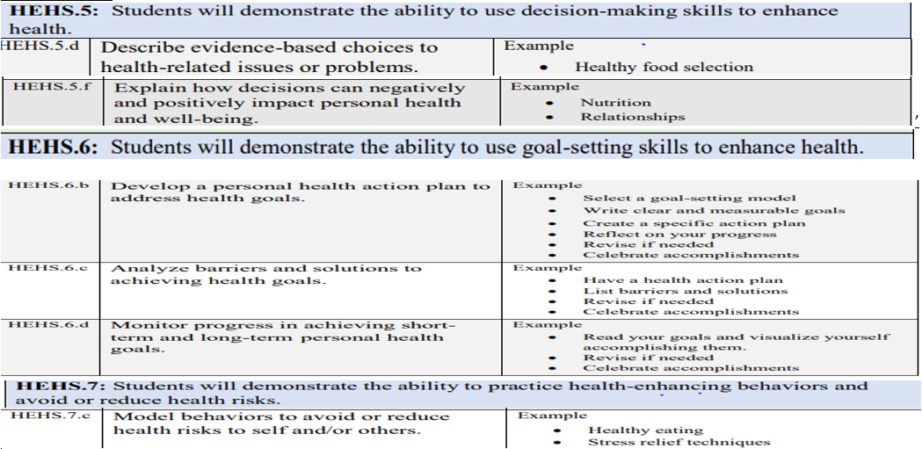

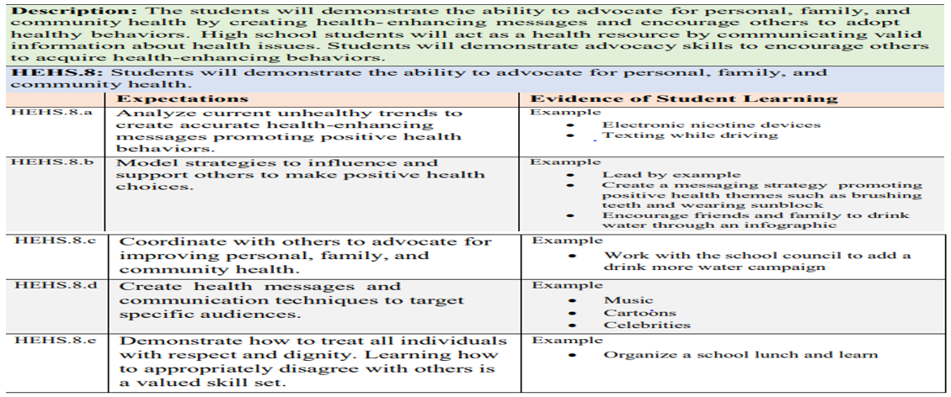

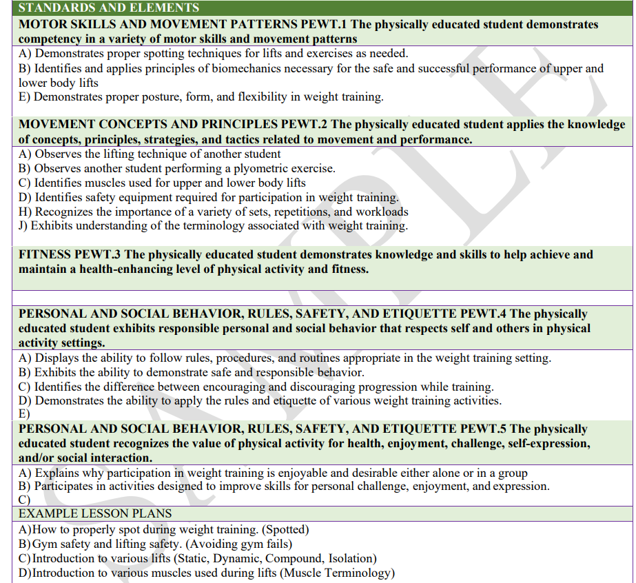

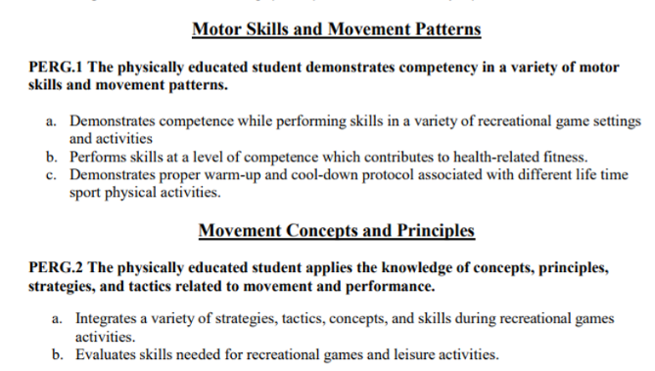

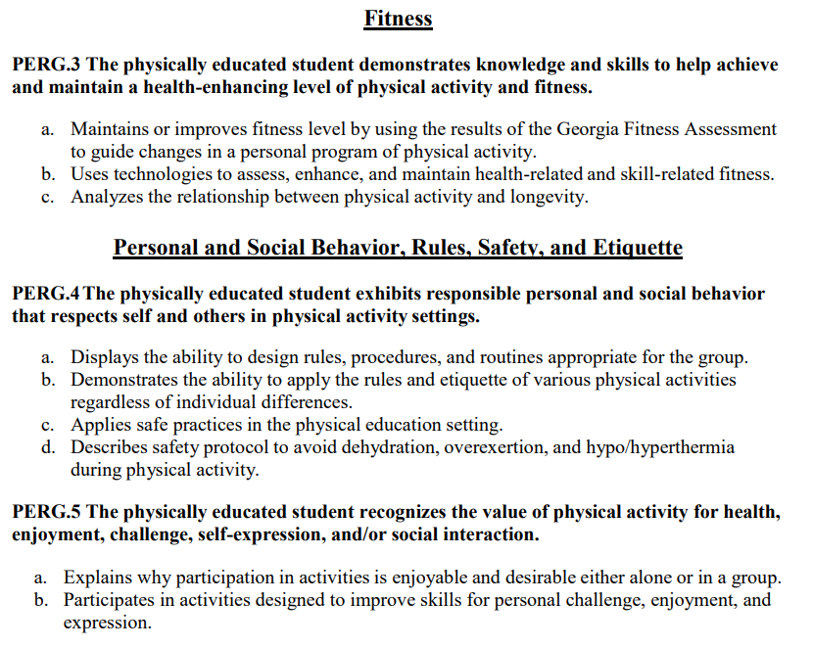

Ping Pong Learning Targets

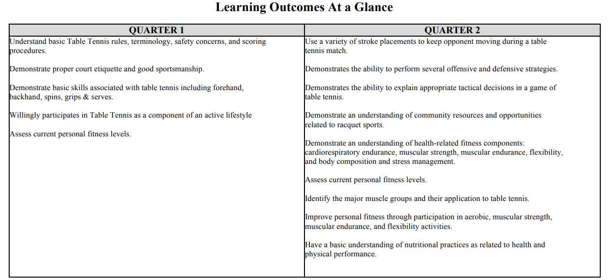

Weight Training Standards

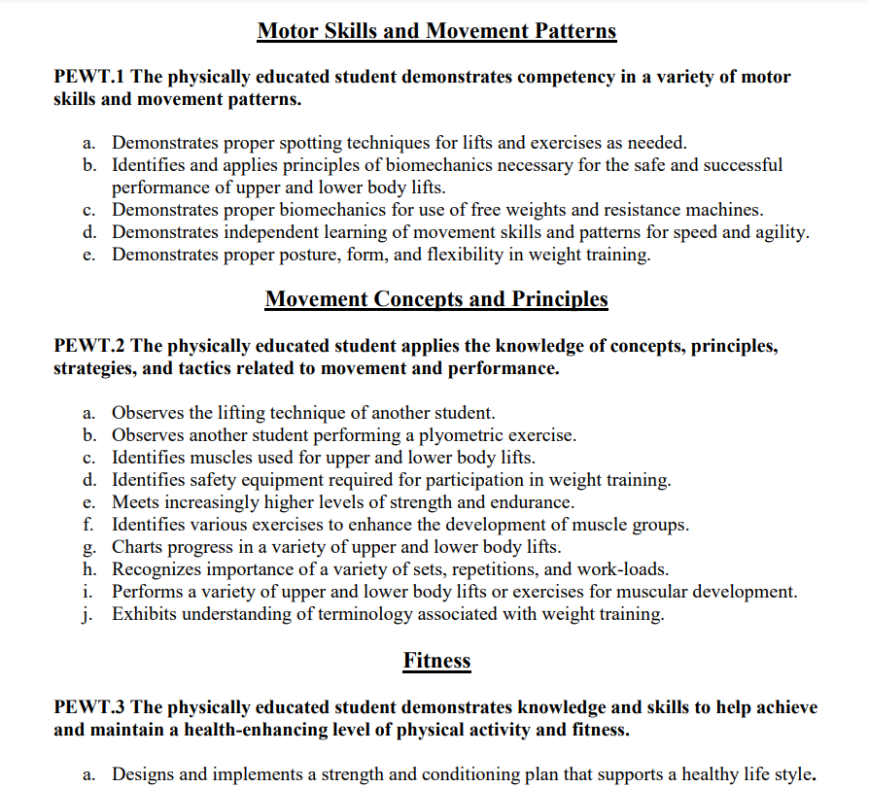

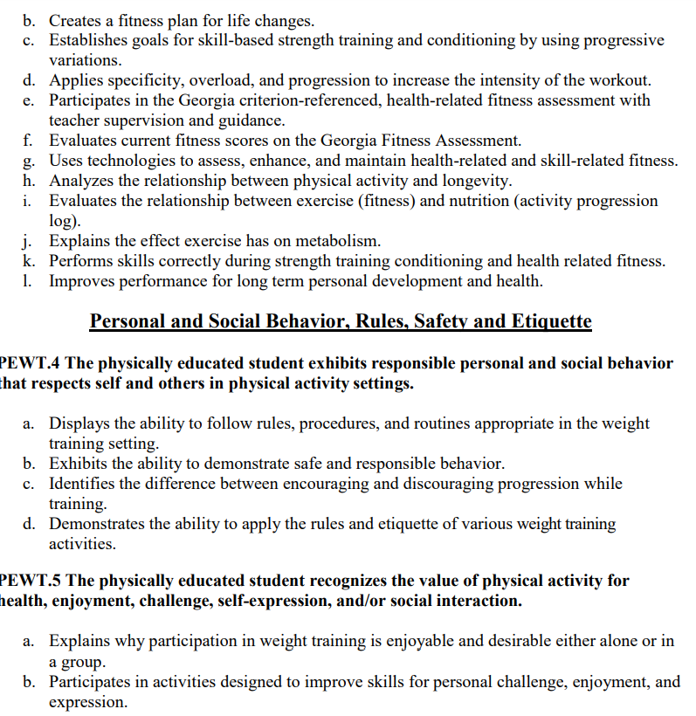

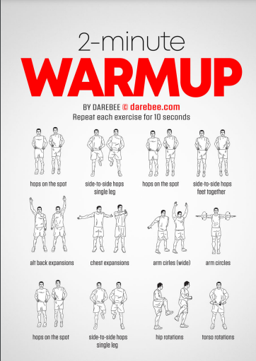

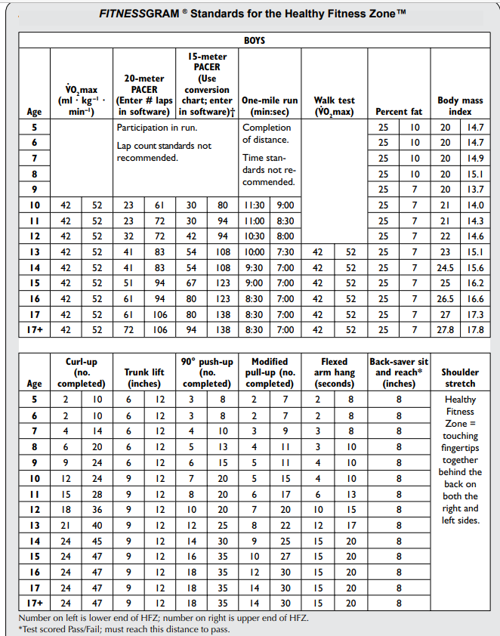

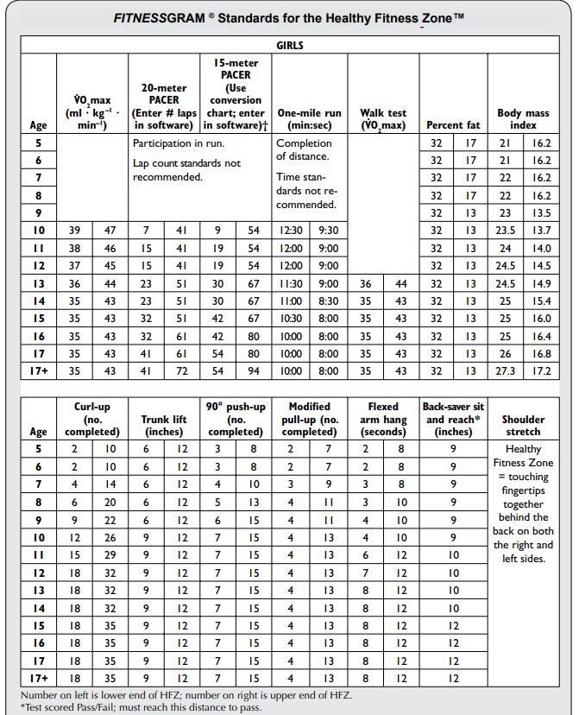

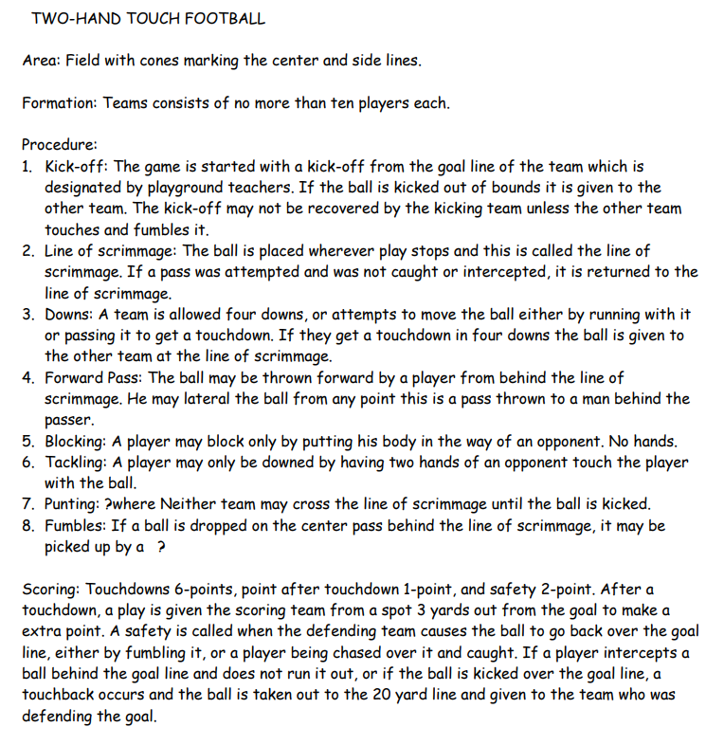

| ◄ March | **April 2024** | | | | | [May ►](#May_2024" \o "Jump to May) |
| --- | --- | --- | --- | --- | --- | --- |
| **Sun** | **Mon** | **Tue** | **Wed** | **Thu** | **Fri** | **Sat** |
| Learning Target:  1.Students can analyze the effectiveness of strength training and cardio based on fitness assessment data.  2. students can explain the steps to best perform double dutch jumping including rope turning  **Success:**  **1.studenrts can answer oral assessment questions on the history and technical skills for double dutch**  **2.students can demonstrate technical skills while participating in double dutch** | 1  **Do Now: hall warmup**  **Classwork:**  **Students will complete assessments & documents data**  **1.crunches: cardio**  **2.jump rope: cardio**  **Closing: review of growth and next steps for**  **Do Now: choosing the best pre survey & attendance**  **Vocab: determination, wisdom, responsibility, honesty, self-respect, boundaries, assertive**  **Classwork:**  **1.Goal setting review of learning target & cold callf for some specific goals students have**  **2.Personal Goal setting page 8 of CTB book (pair share)**  **3. Avoiding Detours Class discussion page 9**  **Closing:round table**  Do Now:  -March Madness  -Sportsmanship discussion & handout  classwarm up & agilities  Classwork:  Video double dutch  Review of tennsi court expectations  Tennis court walk  -students checked off for following practice jump rope swings  Closing: walk back and cool down  1.Relay tic tac toe (best of 3)  *for each round  -runner, taper (put tape on X or O  Do Now: classwarm up & agilities  Classwork:  **Ultimate Frisbee rules review:**  **coaches review game ruels, techniques,**  **Practice skills doing disk toss: (7 consecutive tosses without dropping then take two steps back**  **-take picture of tournament** | 2  **Do Now: class warmup**  **Classwork:Together**  **(bar & dumbbell)**  **3 x 10**  **1.bicep curls**  **2.tricep ext**  **3. upright row**  **4.shoulder press**  **5. chest press**  **Jump Rope Darbee workout 2x**  **Closing: cool down**    **Do Now: page 3 of CTB Close Reading**  **Classwork:**  **1.CTB 14 & 15 Together as Class**  **2.CTB Lesson 3 & 4 One page**  **1.Baby Budget: 40pts (given by coach)**  **2.Top 2 Methods for reducing pregnancy risk-20pts**  **3. 2 facts from How STD’s are spread section on page 27-20pts**  **4. 2 facts about 4 STDs on pages 28 & 29-40 points (name the STDs specifically)**  **5.100% protection practice against STDS-20pts**  **6. 2 images-20pts**  **7.Followed outline & expectations-40pts-200 total**  **Closing: quick review/understanding check-cold call**:  Do Now:  Do Now:  -March Madness  -Sportsmanship discussion & handout  classwarm up & agilities  Classwork:  **Same as Monday**  **Volunteers practice**  **Closing: cool down** | 3  **Do Now: class warmup**  **Classwork:Together**  **(bar & dumbbell)**  **3 x 10**  **1.bicep curls**  **2.tricep ext**  **3. upright row**  **4.shoulder press**  **5. chest press**  **Jump Rope Darbee workout 2x**  **Closing: cool down**  Me **Do Now: CTB avoiding relationship traps video & fill in blanks page 34 & 35**  **Classwork:**  **Lesson 5 & 6 together as a class (Developing Best relationships & Delaying sexual activity)**  **1.Class discussion**  **2. partner share**  **3.independent refelction**  **Closing: reminders & announcements**  ntal & Emotional Health Project  (checklist check)  Do Now:  Do Now:  -March Madness  -Sportsmanship discussion & handout  classwarm up & agilities  Classwork:  Rec Games Rotations  1.Double dutch  2.cornhole  3.Ping Pong  4.Connect 4  5.Punching Bag  6.Notebook check  **In teams, students will demonstrate skills for double dutch following video and guide from coach**  **Closing: cool down** | 4  **Do Now: class warmup**  **Classwork:Together**  **(bar & dumbbell)**  **3 x 10**  **1.bicep curls**  **2.tricep ext**  **3. upright row**  **4.shoulder press**  **5. chest press**  **Jump Rope Darbee workout 2x**  **Closing: cool down**  **Do Now: Close Read brochure assignment instructions**  **Classwork:**  **Students will create Brochure for lesson 7 & 8 including the major topics in the brochure along with best practices**  **Closing: teacher touch on key points**  Do Now:  Do Now:  -March Madness  -Sportsmanship discussion & handout  classwarm up & agilities  Classwork:  **Line Dancing (3 rounds of practice)**  **-j dash wop for wamr up/intro**  **-spiffy the goat throw it**  **-ceelo: ill be around**  **-tamia-I can’t get enough**  **Closing: cool down** | 5  **Do Now: class warmup**  **Classwork:Together**  **(bar & dumbbell)**  **3 x 10**  **1.bicep curls**  **2.tricep ext**  **3. upright row**  **4.shoulder press**  **5. chest press**  **Jump Rope Darbee workout 2x**  **Closing: cool down**  **Do Now: CTB Post survey**  **Classwork: Students will complete missing/incomplete assignments**  **Closing: N/A**  Do Now:  Do Now:  -March Madness  -Sportsmanship discussion & handout  10 minute walk  Classwork:  Free Play:  Basketball  Football  Volleyball  Soccer-  Closing: Cool down last 5 minutes | 6 |
| 7 | 8  Spring Break | 9  Spring Break | 10  Spring Break | 11  Spring Break | 12  Spring Break | 13 |
| 14 | 15  Spring Break | 16  Do Now: warmup (hallway)  Classwork:  Class workout together (dumbbells or weighted bar)  3 x 10  -shoulder press  -deadlift  -upright row  -double lunges  -bicep curls  -squats  (2 machines each with 2 students per machine)  -bench press  -leg ext  **Do Now:**  1.Write a five sentence summary about your break including how some of your choices were postivie towards your overall health  Do Now:  1.Review of Movie watching expectations  Classwork:  Students watch  with review questions in mind  Closing: cold call on students to review what has been viewed thus far and the connection with our course standards | 17  Do Now: warmup (hallway)  Classwork:  Class workout together (dumbbells or weighted bar)  3 x 10  -shoulder press  -deadlift  -upright row  -double lunges  -bicep curls  -squats  (2 machines each with 2 students per machine)  -bench press  -leg ext  **Do Now:**  **1.What is your SMART goal for this class?**  **2.Are you on track to meet your SMART goal for this class?**  **3. What can you do to make sure you remain on track or get on track to meet your SMArt GOAL**  **Classwork:**  **Work on missing CTB assignments**  Do Now:  Notebook setup to answer “ review questions  Classwork:  “ review questions Part A  Closing:round table | 18  Do Now: warmup (hallway)  Classwork:  Class workout together (dumbbells or weighted bar)  3 x 10  -shoulder press  -deadlift  -upright row  -double lunges  -bicep curls  -squats  (2 machines each with 2 students per machine)  -bench press  -leg ext  **Do Now:**  **1.What is your current grade in this class?**  **2. Why is your notebook essential to your overall grade for this class?**  Movie Day  Do Now:  Notebook setup to answer “ review questions  Classwork:  “ ” review questions Part B  Free Play if time permits  Closing:round table | 19  Rest Day  Makeup Day | 20 |
| 21  Learning Target:  1.I can explain the importance of performing both upper and lower body exercises  Success:  1.Students can perform a variety of upper and lower body strength and endurance exercises using the proper biomechanics/technique  2.Student can meet high levels of strength training  Learning Target:  1.I can work toward passing Health and receiving credit  Success:  Students can use rubric provided by teacher to work on notebook organization and/or missing assignments | 22  Do Now: warm up (3 minutes)  Classwork:  1.leg lifts on pull up bar  2.Chest press-shoulder press  3.calf raises-squats  4. Tricep dips  5.increasing lunges to 5  6.Increasing lunges  7.Bicep curls lateral lifts  Closing: cool down  Do Now: Jump In Movie questions access sign off on expectations (assignment due Nov. 16th)  Classwork:  Warm up  Fitness Circuit  Closing: cool down    (Remember this should be on a new sheet in the classwork sections of your notebook and all of the Do Now’s for this week should be on one page (the front filled up before the back is used) in order to get credit for them all  1.What is your SMART goal for this class  2.What is your current grade in this class?  3.Are on track to meet your SMART goal for this class?  Class work: 11/13/23  1.Heading: Reflection of My Qualities  2.For 1-7 on page 119,  a.Write the number  b.Write the heading next to the number  c.List 3 responses that apply to you under each number/heading  Establishing Healthy Relationships-skit option  (packet work done in notebook) Ch.14 & 15 | 23  Do Now: warm up (3 minutes)  Classwork:  1.leg lifts on pull up bar  2.Chest press-shoulder press  3.calf raises-squats  4. Tricep dips  5.increasing lunges to 5  6.Increasing lunges  7.Bicep curls lateral lifts  Closing: cool down  Do Now: Warm up exercises  Classwork:  Fitness Circuit  Closing: cool down  Do Now:Copy from board  Classwork:  1.Project roll out  2. Notebook organization using rubric/chunking/etc.  Closing:n/a  Establishing Healthy Relationships  (packet work done in notebook) | 24  Do Now: warm up (3 minutes)  Classwork:  1.leg lifts on pull up bar  2.Chest press-shoulder press  3.calf raises-squats  4. Tricep dips  5.increasing lunges to 5  6.Increasing lunges  7.Bicep curls lateral lifts  Closing: cool down  Do Now: Warm up exercises  Classwork:  Provided time to work on “Jump In Movie Questions” in class  Closing: Students aask questions pertaining to assignment and expecttions  Do Now: 1..When should you have your posters in class for the self-identity project?  2.When is the self-identity project due?  Classwork:  1.Notebook organization based on rubric | 25  Do Now: warm up (3 minutes)  Classwork:  1.leg lifts on pull up bar  2.Chest press-shoulder press  3.calf raises-squats  4. Tricep dips  5.increasing lunges to 5  6.Increasing lunges  7.Bicep curls lateral lifts  Closing: cool down  Do Now: Notebooks checked  Classwork: Free Day-participate in various activities in gym  Closing: N/A  Establishing Healthy Relationships  (packet work done in notebook)  DO Now: 1. Have you completed your notebook organizations?  2.When should notebooks be completed for final exam grade?  Classwork:  1.project rough draft completion using rubric  Closing: Questions about project below rough draft | 26  Stretch & Rest Day  Do Now: N/A  Classwork: Make up Day & Free Day  -Those that need to makeup any assignments will do so according to coaches’ explained expectations  Closing: N/A  Establishing Healthy Relationships  (packet work done in notebook)  Do Now:  None  Classwork: Project rough draft completion (index card focus)  -progress check with teacher | 27 |
| 28 | 29  Do Now: 3 minute warm up (hallway)  Classwork:  3 set ; 10 reps  Darbee Push Pull Leg Workout  Closing:  Fill in fitness journal  cool down & water  Do Now & Classwork: same as weight training done as class  Student conferences & parent contact  Do Now:  Choosing the Best Post survey  1.When should you have your poster at school for your project?  2.When is your project due?  3.Why are we working on notebook organization in class?  Classwork:  Student will work on notebook organization using rubric and chunking from teacher | 30  Do Now: 3 minute warm up (hallway)  Classwork:  3 set ; 10 reps  Darbee Benched workout (some can be done on the mat)  Closing: cool down & water  Do Now & Classwork: same as weight training done as class  Student conferences & parent contact  Protecting your Health Ch. 16 & 17  Do Now:  1.When should you have your poster in class for your project?  2. When is your project due?  Classwork:  Notebook organization | Sports Mental Strength Touch Football video:  <https://www.youtube.com/watch?v=Zyar1U6mgz4> | | | |

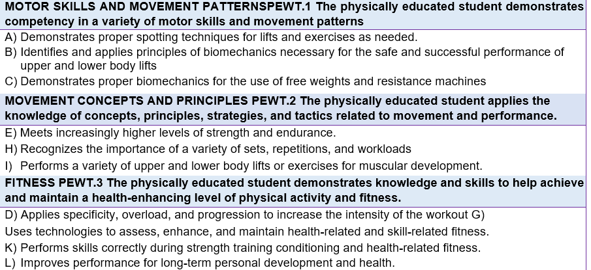

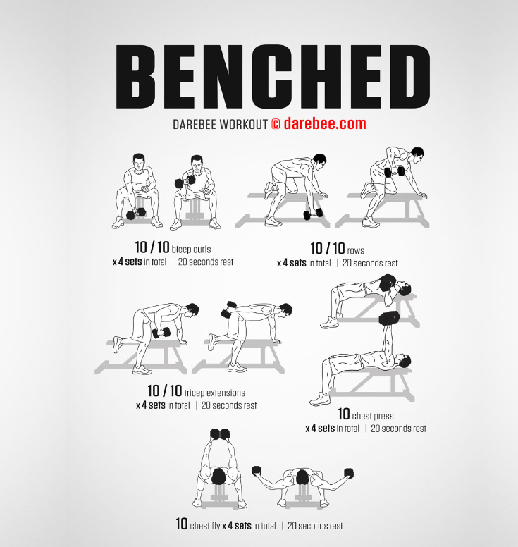

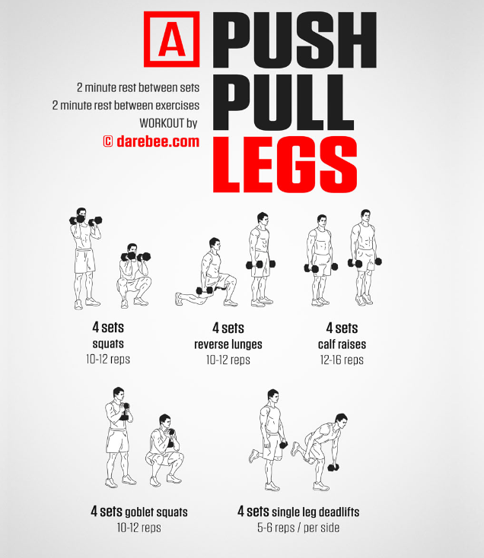

| ◄ April | **May 2024** | | | | | [June ►](#June_2024" \o "Jump to June) |
| --- | --- | --- | --- | --- | --- | --- |
| **Sun** | **Mon** | **Tue** | **Wed** | **Thu** | **Fri** | **Sat** |
|  |  |  | 1  Do Now: 3 minute warm up (hallway)  Classwork:  3 set ; 10 reps  Darbee Push Pull Leg Workout  Closing: cool down & water  Do Now: review of Fitnessgram expectations  Classwork: Fitness gram  Push ups & curl ups  Protecting your Health Ch. 16 & 17 Podcast Assignment/Project  Do Now:  1.Do you have your poster today?  2.How long have you had to get your poster for your project?  Classwork:  Students will work on project using rubric and examples provided by teacher  -Those without poster will complete reflection & continue to work on notebook organization | 2  Do Now: 3 minute warm up (hallway)  Classwork:  3 set ; 10 reps  Darbee Benched workout (some can be done on the mat)  Closing: cool down & water  Do Now: review of Fitnessgram expectations  Classwork: Fitness gram  15 m pacer test  Protecting your Health Ch. 16 & 17  Do Now:  Classwork: Students continue to work on poster and notebook organization | 3  Do Now: reminder of fitness journal expectations  Classwork:  Notebook check  Gym if time permits (free time/rest day)  Closing: N/A  Do Now: makeup day expectations  Classwork: makeup & free day for those that are done  Protecting your Health Ch. 16 & 17 Project & notebook update & self reflection of progress | 4 |
| 5 | 6  Students complete self-created strength workout with at least 4 upper body & 4 lower body exercises  DO Now:  Video of Adele Hello ball challenge’  Work Session:  Students work on challenge with partner  Understanding Disease & Disorders (Ch.18-20)  -one pager  Do Now:  1.Complete Project check sheet  Classwork:  Students will use rubric & chunking from teacher to complete notebook organization  -teacher will call students for project progress conferences using check sheet  Closing: N/A | 7  Understanding Disease & Disorders (Ch.18-20)  -one pager  DO Now:  Video of Adele Hello ball challenge’  Work Session:  Students work on challenge with partner  Do Now:  1.Complete Project check sheet  Classwork:  Students will use rubric & chunking from teacher to complete notebook organization  -teacher will call students for project progress conferences using check sheet  Closing: N/A | 8  Students complete self-created strength workout with at least 4 upper body & 4 lower body exercises  DO Now:  Video of Adele Hello ball challenge’  Work Session:  Students work on challenge with partner  Understanding Disease & Disorders (Ch.18-20)  -one pager  Do Now:  1.Notebook Organization check sheet  Classwork:  Students will use rubric & chunking from teacher to complete notebook organization  -teacher will call students for project progress conferences using check sheet | 9  Students complete self-created strength workout with at least 4 upper body & 4 lower body exercises  Students complete Adele ball challenge  Final Exam Study guide  Do Now:  N/A  Classwork:  Students will use rubric & chunking from teacher to complete notebook organization  -teacher will call students for project progress conferences using check sheet | 10  Final Exam Study guide  Do Now:  Peer Review of Presentations (glows & grows)  Classwork:  Project Presentations | 11 |
| 12 | 13  Final Fitness Assessment  *Bench Max  *Crunches  Prepare for Final Exam  **Notebook DUE**  Final Exam Study guide  Do Now: students collect Final Exam study guide  Classwork: student complete final exam study guide  Closing: N/A | 14  Final Fitness  Assessment  *Jump Rope Burn Out  *Burn Out Squat  Prepare for Final Exam  Final Exam Study guide  Review  Do Now: complete study guide for final exam (20 minutes)  Classwork: study guide review  Closing: N/A | 15  Turn In Fitness Journal  Prepare for Final Exam  Final Exam Study guide  Review with peers | 16  Prepare for Final Exam  Ask questions & review | 17  Semester Exams  Student study & complete final exam | 18 |
| 19 | 20  Semester Exams  Student study & complete final exam | 21  Semester Exams  Student study & complete final exam | 22  Semester Exams  (1/2 day)  Student study & complete final exam | 23  Post Planning | 24  Post Planning | 25 |
| 26 | 27  Memorial Day Holiday | 28 | 29 | 30 | 31 |  |

USC vs. LSU Women’s Basketball Game Questions

1. Which teams were playing?
2. List each team and the head coach for each team
3. List each team and two of their key players
4. Why is this game significant?
5. List four rules of the game of basketball
6. In at least four complete sentneces, describe the overall game including at least two memorable highlights.
7. Based on the overall game, list three valuable lesson you can take away from the game.

| ◄ May | **June 2024** | | | | | [July ►](#July_2024" \o "Jump to July) |
| --- | --- | --- | --- | --- | --- | --- |
| **Sun** | **Mon** | **Tue** | **Wed** | **Thu** | **Fri** | **Sat** |
|  |  |  |  |  |  | 1 |
| 2 | 3 | 4 | 5 | 6 | 7 | 8 |
| 9 | 10 | 11 | 12 | 13 | 14 | 15 |
| 16 | 17 | 18 | 19 | 20 | 21 | 22 |
| 23 | 24 | 25 | 26 | 27 | 28 | 29 |
| 30 |  | | | | | |

| ◄ June | **July 2024** | | | | | [August ►](#August_2024" \o "Jump to August) |
| --- | --- | --- | --- | --- | --- | --- |
| **Sun** | **Mon** | **Tue** | **Wed** | **Thu** | **Fri** | **Sat** |
|  | 1 | 2 | 3 | 4 | 5 | 6 |
| 7 | 8 | 9 | 10 | 11 | 12 | 13 |
| 14 | 15 | 16 | 17 | 18 | 19 | 20 |
| 21 | 22 | 23 | 24 | 25 | 26 | 27 |
| 28 | 29 | 30 | 31 |  | | |

| ◄ July | **August 2024** | | | | | [September ►](#September_2024" \o "Jump to September) |
| --- | --- | --- | --- | --- | --- | --- |
| **Sun** | **Mon** | **Tue** | **Wed** | **Thu** | **Fri** | **Sat** |
|  |  |  |  | 1 | 2 | 3 |
| 4 | 5 | 6 | 7 | 8 | 9 | 10 |
| 11 | 12 | 13 | 14 | 15 | 16 | 17 |
| 18 | 19 | 20 | 21 | 22 | 23 | 24 |
| 25 | 26 | 27 | 28 | 29 | 30 | 31 |

| ◄ August | **September 2024** | | | | | [October ►](#October_2024" \o "Jump to October) |
| --- | --- | --- | --- | --- | --- | --- |
| **Sun** | **Mon** | **Tue** | **Wed** | **Thu** | **Fri** | **Sat** |
| 1 | 2 | 3 | 4 | 5 | 6 | 7 |
| 8 | 9 | 10 | 11 | 12 | 13 | 14 |
| 15 | 16 | 17 | 18 | 19 | 20 | 21 |
| 22 | 23 | 24 | 25 | 26 | 27 | 28 |
| 29 | 30 |  | | | | |

| ◄ September | **October 2024** | | | | | [November ►](#November_2024" \o "Jump to November) |
| --- | --- | --- | --- | --- | --- | --- |
| **Sun** | **Mon** | **Tue** | **Wed** | **Thu** | **Fri** | **Sat** |
|  |  | 1 | 2 | 3 | 4 | 5 |
| 6 | 7 | 8 | 9 | 10 | 11 | 12 |
| 13 | 14 | 15 | 16 | 17 | 18 | 19 |
| 20 | 21 | 22 | 23 | 24 | 25 | 26 |
| 27 | 28 | 29 | 30 | 31 |  | |

| ◄ October | **November 2024** | | | | | [December ►](#December_2024" \o "Jump to December) |
| --- | --- | --- | --- | --- | --- | --- |
| **Sun** | **Mon** | **Tue** | **Wed** | **Thu** | **Fri** | **Sat** |
|  |  |  |  |  | 1 | 2 |
| 3 | 4 | 5 | 6 | 7 | 8 | 9 |
| 10 | 11 | 12 | 13 | 14 | 15 | 16 |
| 17 | 18 | 19 | 20 | 21 | 22 | 23 |
| 24 | 25 | 26 | 27 | 28 | 29 | 30 |

| ◄ November | **December 2024** | | | | | [January ►](https://www.wincalendar.com/Holiday-Calendar/January-2025" \o "January 2025) |
| --- | --- | --- | --- | --- | --- | --- |
| **Sun** | **Mon** | **Tue** | **Wed** | **Thu** | **Fri** | **Sat** |
| 1 | 2 | 3 | 4 | 5 | 6 | 7 |
| 8 | 9 | 10 | 11 | 12 | 13 | 14 |
| 15 | 16 | 17 | 18 | 19 | 20 | 21 |
| 22 | 23 | 24 | 25 | 26 | 27 | 28 |
| 29 | 30 | 31 |  | | | |